**Solution Problem 1**

We were given information on the population mean and population standard deviation. To find the population variance, simply **follow the steps** in the table below.

|  |  |
| --- | --- |
| **Measure** | **Description** |
| 1. Remember that the variance is simply the square of the standard deviation | \[ (\sqrt{\sigma^2}) = \sigma \] |
| 2.To find the population variance, simply take the square of the population SD | \[ (\sigma)^2 = \sigma^2 \]  \[ 4^2 = 16 \] |

**Solution Problem 2**

To find the variance of the data, simply follow the formula,

\[ s^2 = \frac{\Sigma(x_{i}-\bar{x})^2}{n-1} \]

Where the **mean** is,

\[ \bar{x} = \dfrac{224}{7} = 32 \]

|  |  |  |
| --- | --- | --- |
| **Observation** | **Value** | **(x_{i}-\bar{x})^2** |
| 1 | 25 | 49 |
| 2 | 26 | 36 |
| 3 | 38 | 36 |
| 4 | 45 | 169 |
| 5 | 31 | 1 |
| 6 | 30 | 4 |
| 7 | 29 | 9 |
| Total | 224 | 304 |

Plugging this into the formula, we get,

\[ \dfrac{304}{7-1} = 50.7 \]

Looking at the graph below, we can see the mean and **standard deviation** plotted.

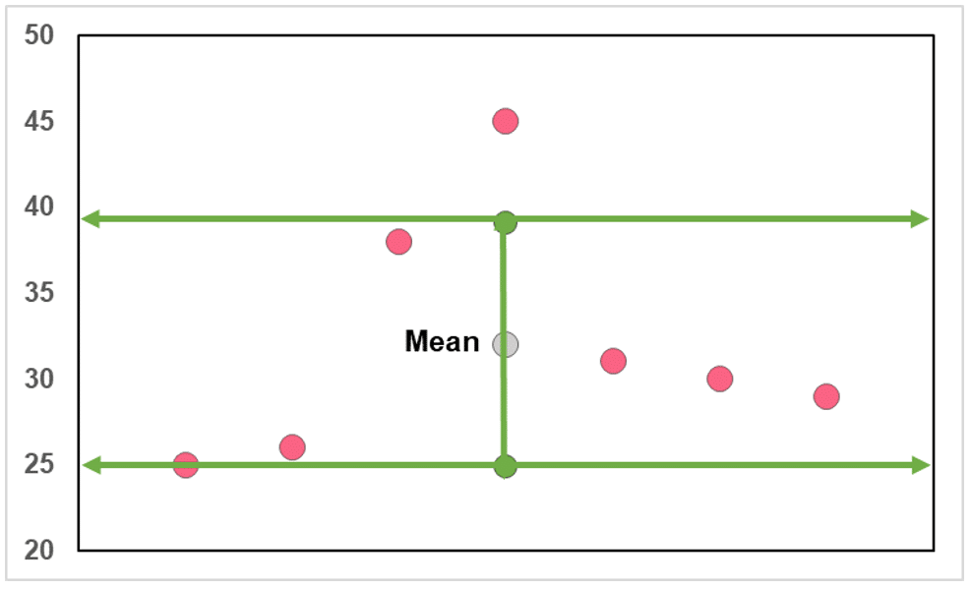

Which may be more clear when plotted on a single axis.

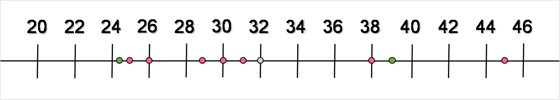

**Solution Problem 3**

As in the previous example, we can **calculate** the sample variance by taking the square of the SD.

|  |  |  |  |
| --- | --- | --- | --- |
|  | **Mean** | **SD** | **Variance** |
| **Data Set M** | 715 | 55 | \[ =55^2 = 3025 \] |
| **Data Set D** | 634 | 42 | \[ =42^2 = 1764 \] |